**CS PRACTIALS**

**Ex 1: Write a program to calculate the factorial of an integer**

**SOURCE CODE:**

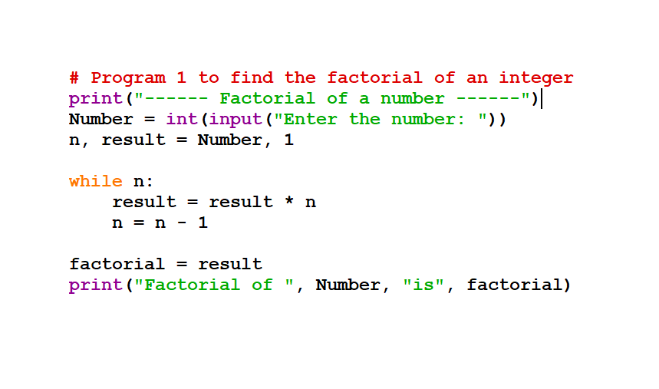

**INPUT/OUTPUT**

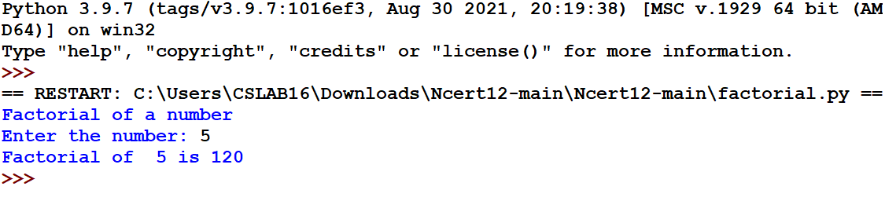

**Ex 2: Write a program to print Fibonacci series**

**SOURCE CODE:**

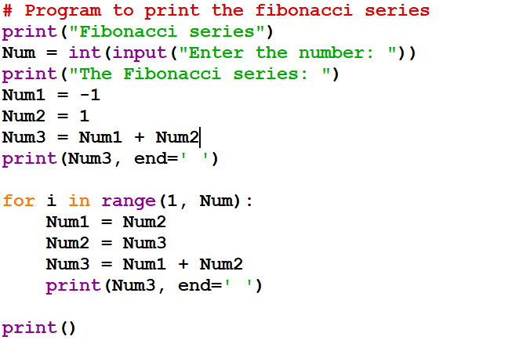

**INPUT/OUTPUT:**

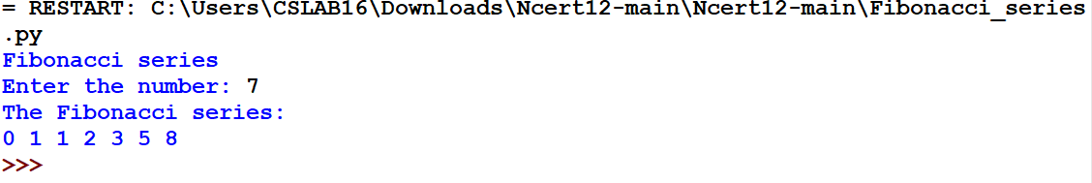

**EX 3: Write a python program to sum the sequence given below. Take the input n from the user: 1 + 1/1! + 1/2! + …. + 1/n!**

**SOURCE CODE:**

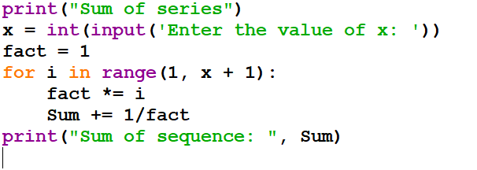

**INPUT/OUTPUT:**

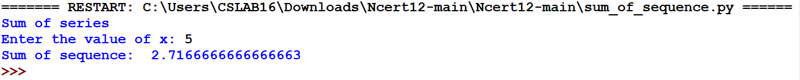

**EX 4: Write a python program for Linear Search**

**SOURCE CODE:**

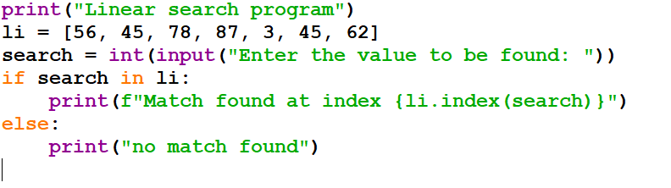

**INPUT/OUTPUT:**

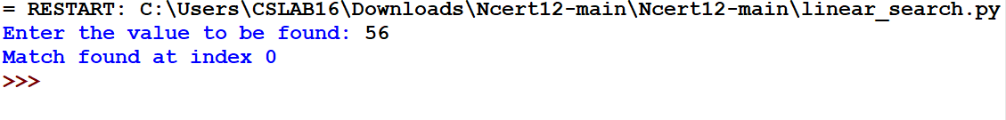

**EX 5: Write a program to check a number whether it is palindrome or not**

**SOURCE CODE:**

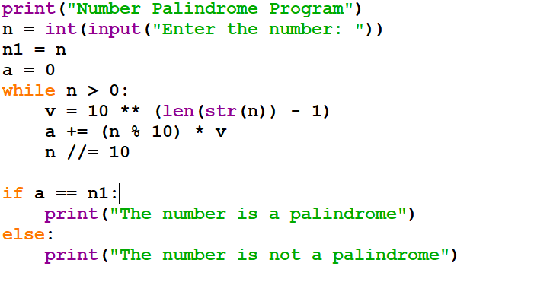

**INPUT/OUTPUT:**

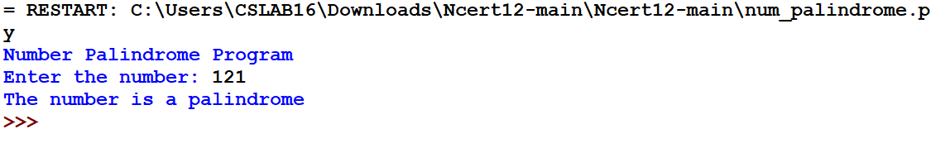

**EX 6: Write a program to read a text file line by line and display each word separated by ‘#’**

**SOURCE CODE:**

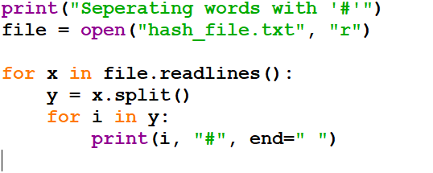

**INPUT/OUTPUT:**

